CDH Install in Localhost

First, we need to install the latest version of Pega PRPC.

Then we need to have the CDH file core zip to Import with us.

After personal edition installation, we need to login into our operator ID or else we need to create the operator.

And after login in, we would see the below screen.

We need to create DSS for Pega-Engine by default ruleset.

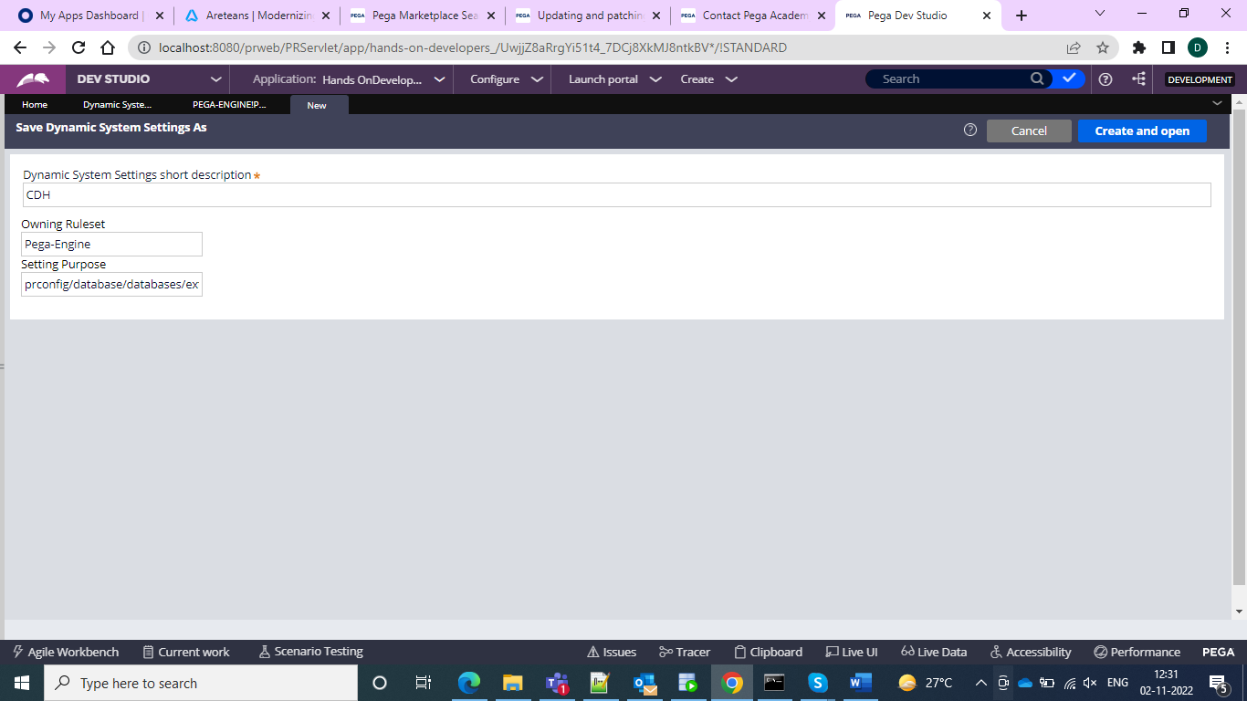

And in the value, we need to give the value as the “externlmktdata” because CDH is the marketing framework

And in the set purpose, we can give it as below

config/database/databases/ExternalMKTData/default schema/default

and then we can go for the value

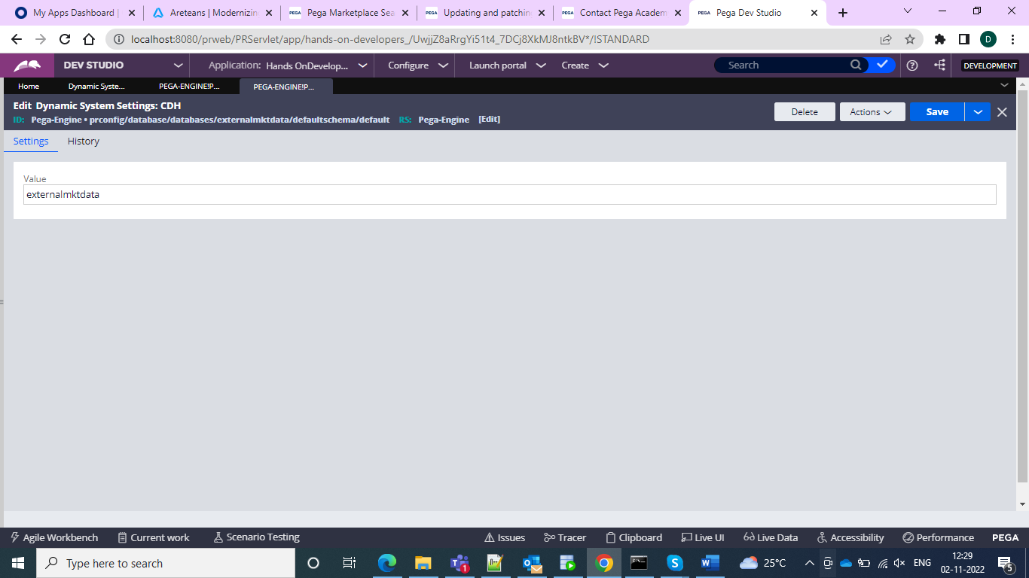

And then we can again create another DSS and then here we need to give the setting purpose for the data source so again under Pega-Engine we can do the Save-As and give the setting purposes as

java:comp/env/jdbc/PegaRULES



And then we can go for the value and give the JDBC database connection

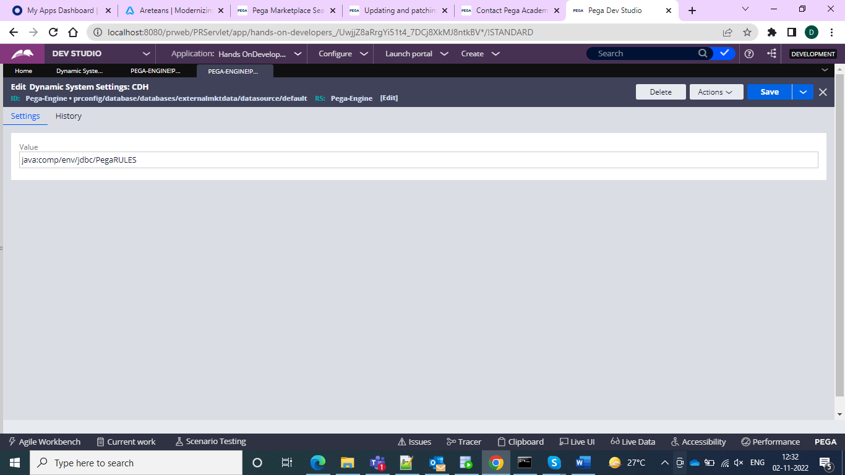

So after all these DSS creations navigate into your system file explorer local Disk C and then navigate to the Pega PRPC/ Pega personal edition folder then go for pgsql and go for pgAdmin4 and then go for the bin folder.

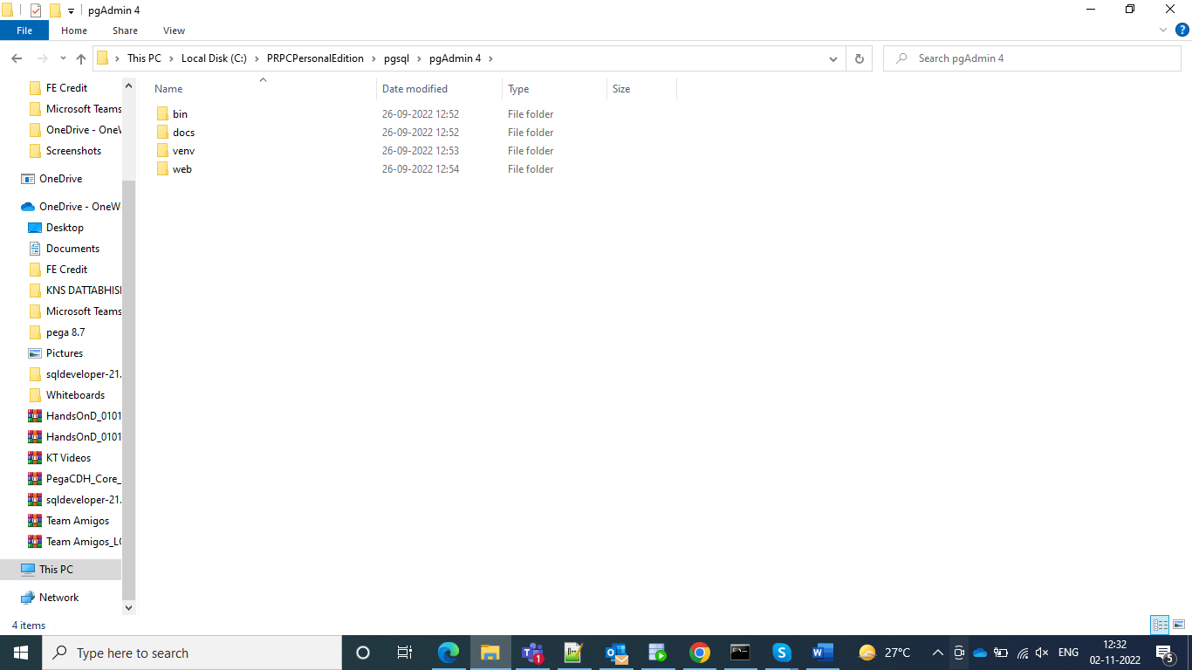

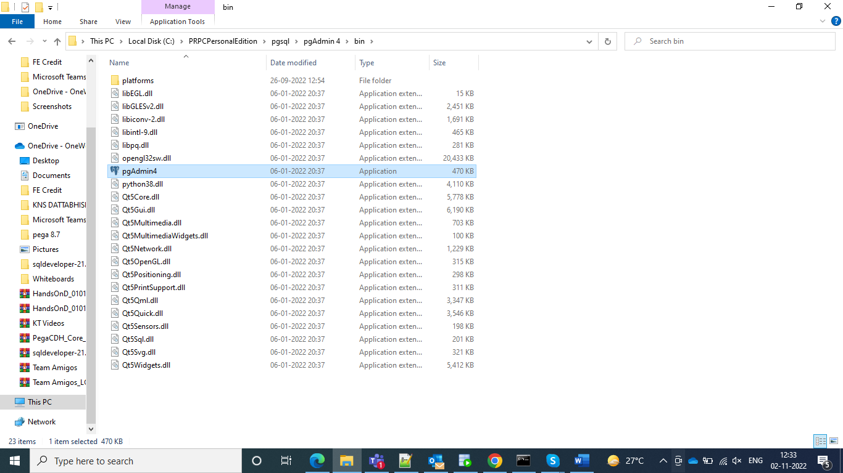

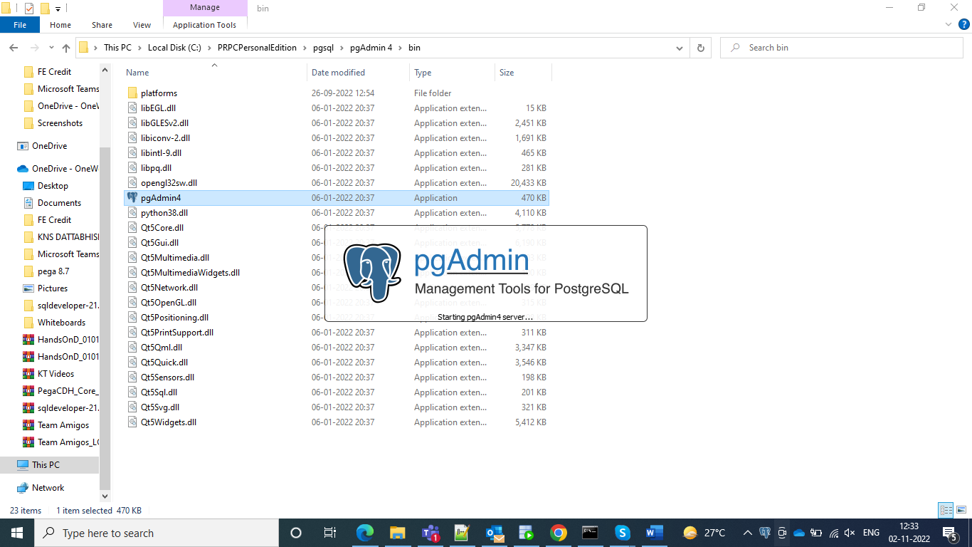

And then open the SQL in the browser

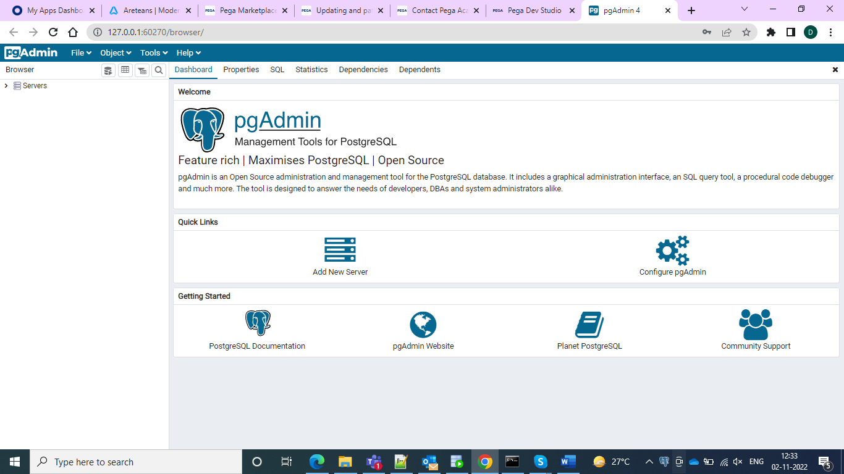

And give passwords as rules

And then right click on the server and give a name I gave as PegaCDH

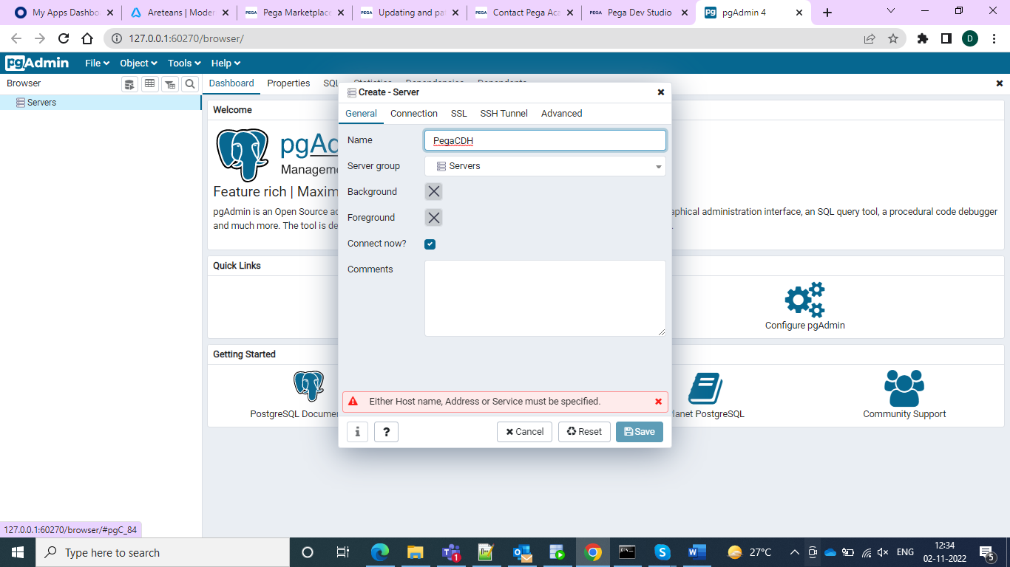

And then go for the server and right-click on the Login/group roles

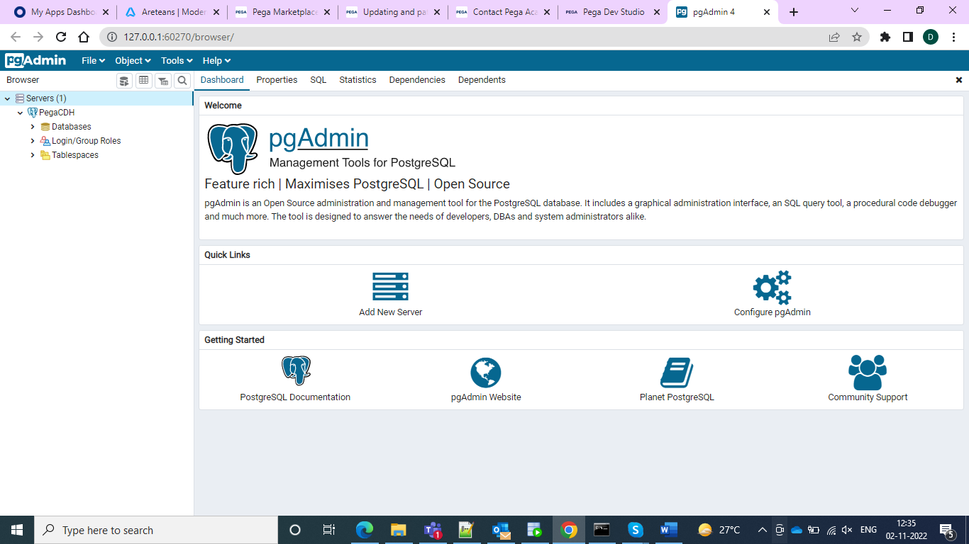

And then give the name as mkt_user because it is a marketing user and the framework and then go for the definition tab and give the password as rules

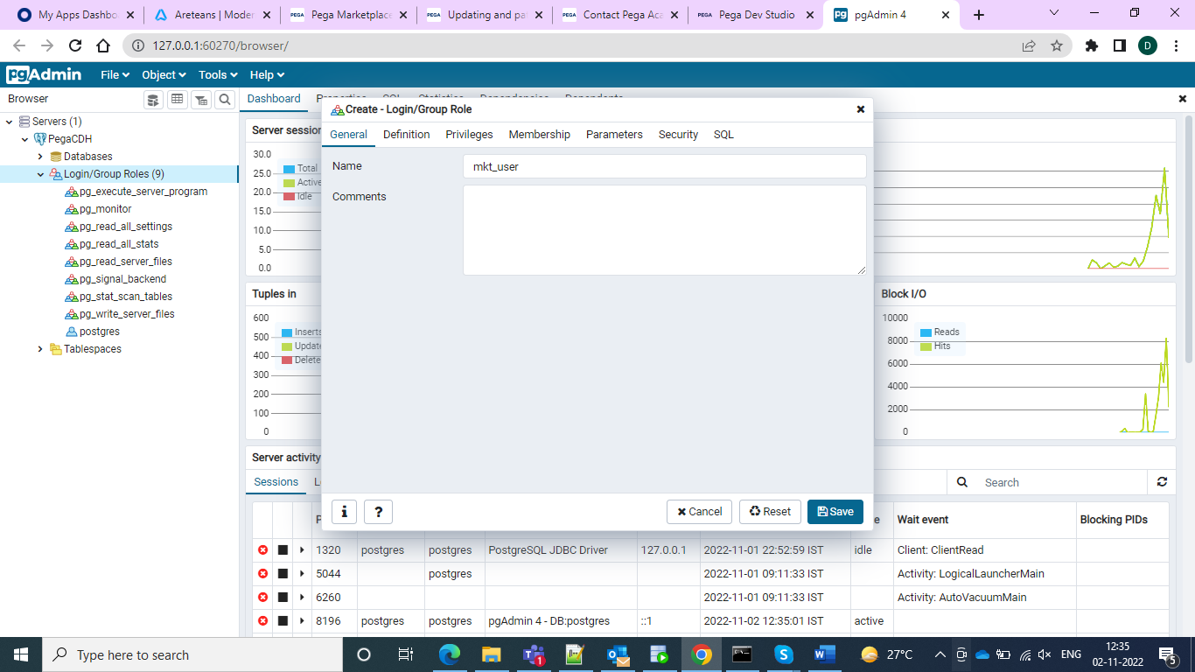

And then go for the privileges tab and enable all the privileges and in the membership give roles as Postgres

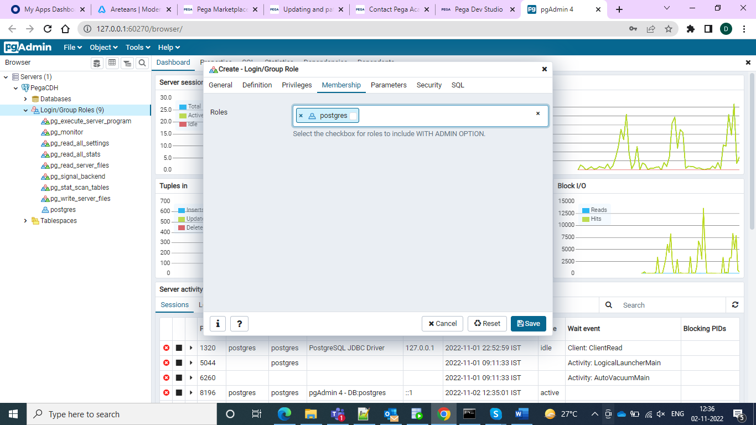

And go to the parameters and specify the name and value and database as search_path externalmktdata and Postgres as the database and save you would see the following

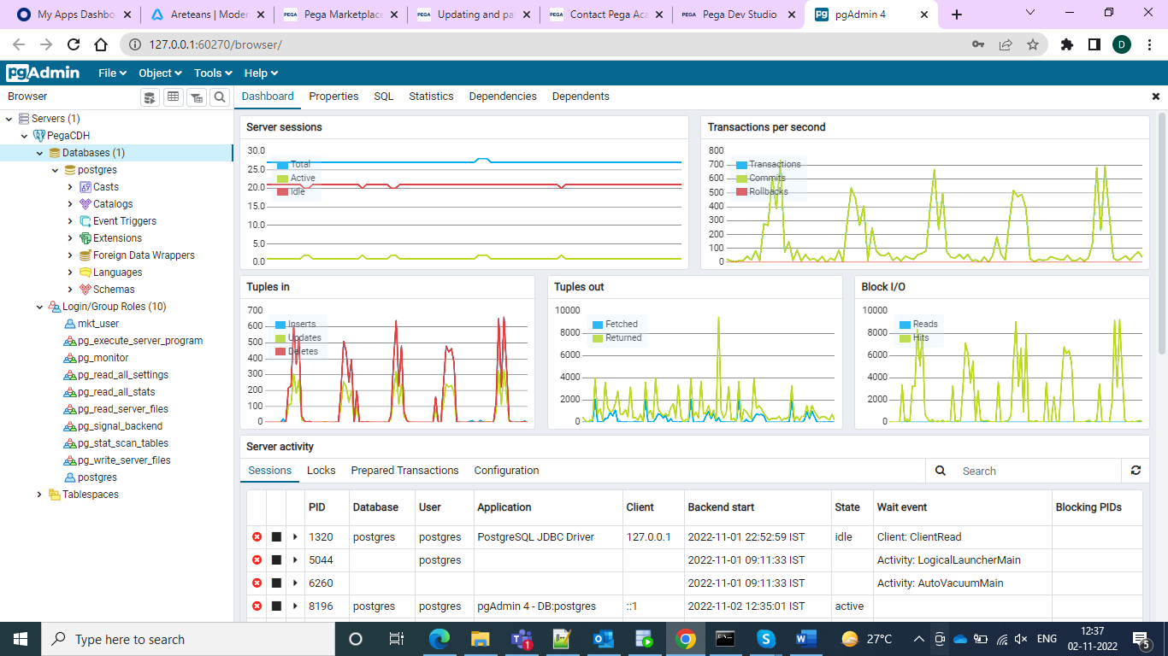and then go for the schema on the left and right click and create the schema

And in the security tab give the grant as mkt_user and enable all the privileges and grant give it as Postgres SQL

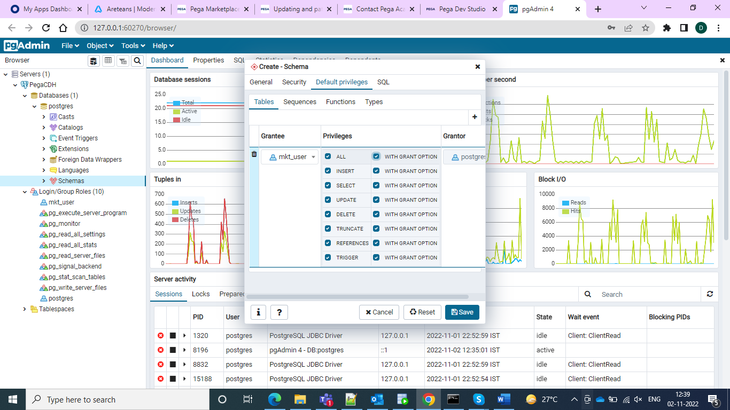

And after this one do a save and then we can go for our local disk C and then go for the tomcat folder in the prpc personal edition folder open it you would find one context by default XML file with javascript coding and this is for default Pega running and we need to replace it with the new context name of the JDBC which we gave in the DSS to recognize the CDH

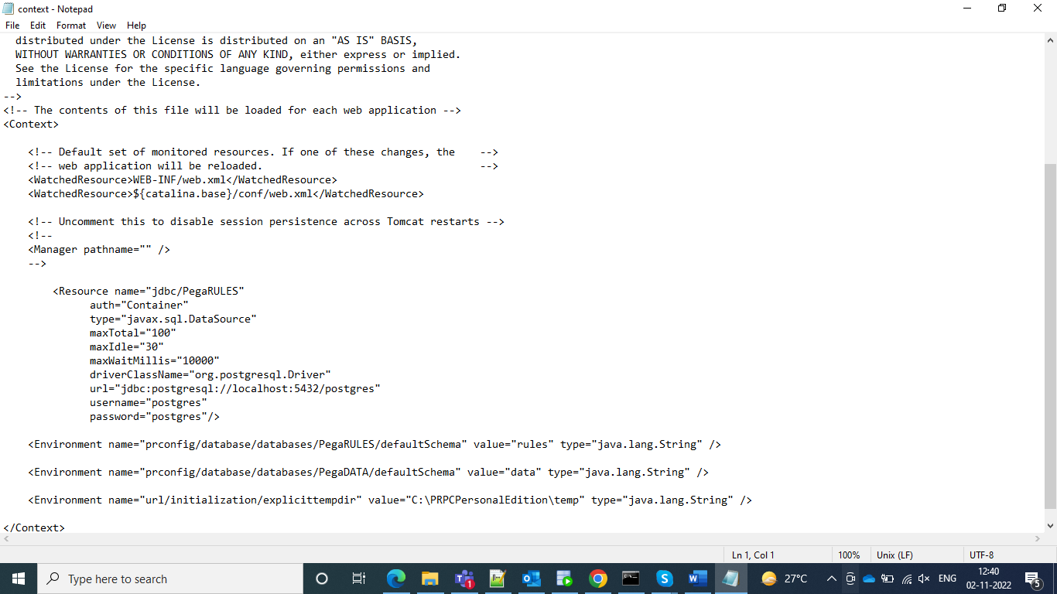

This is the default context and replaces with a new context for the new DSS in that we have the new context and it would be

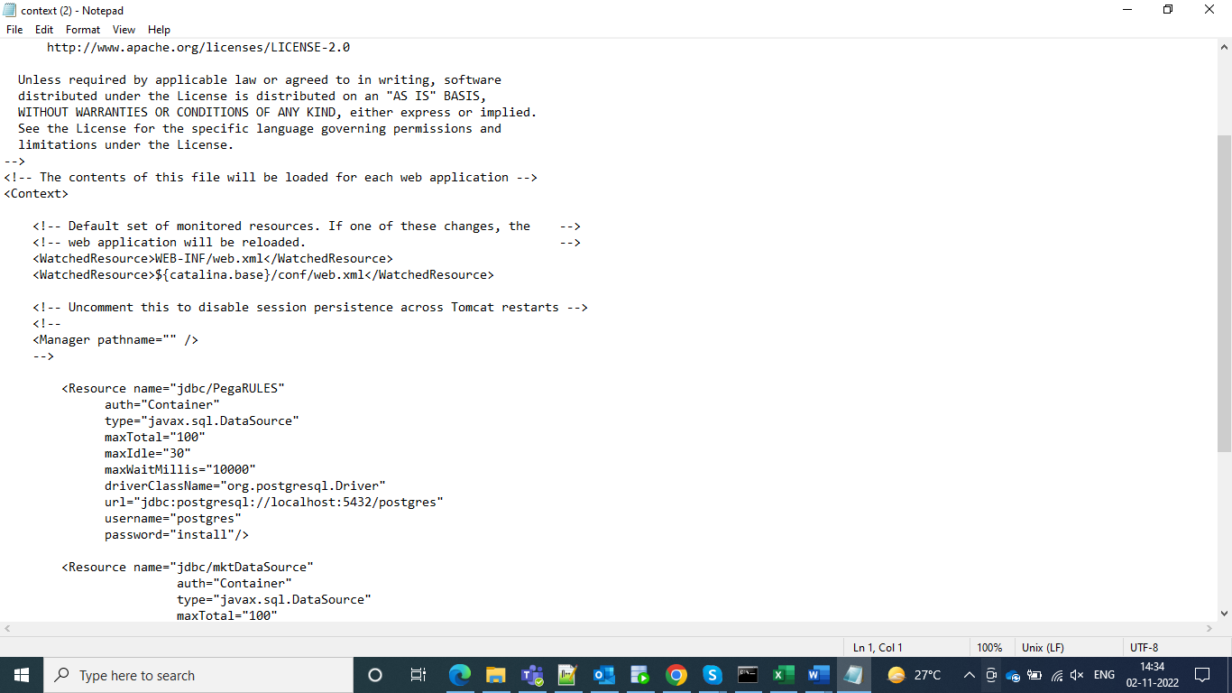

And then we can save this and restart the server

And then go for the database and open externalMKTData and in the integration system we need to give as Pega

And in How to connect we have to select the user configuration in the preferences

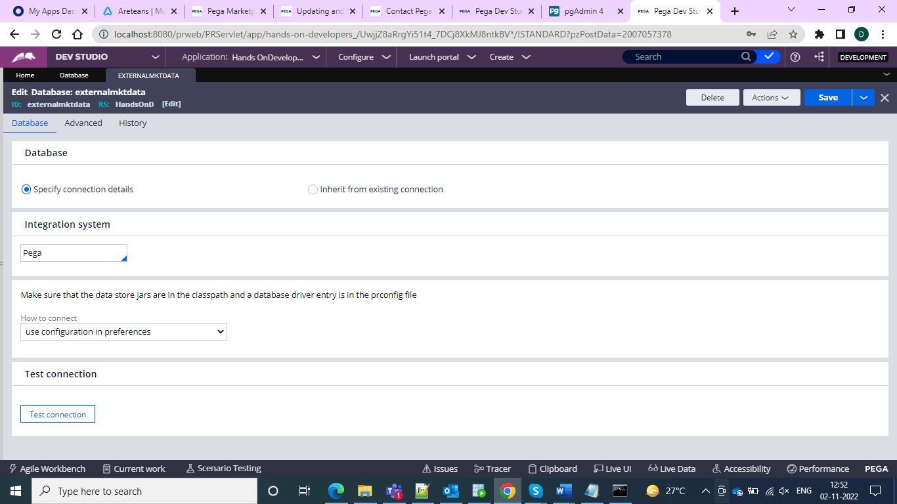

And can test the connection

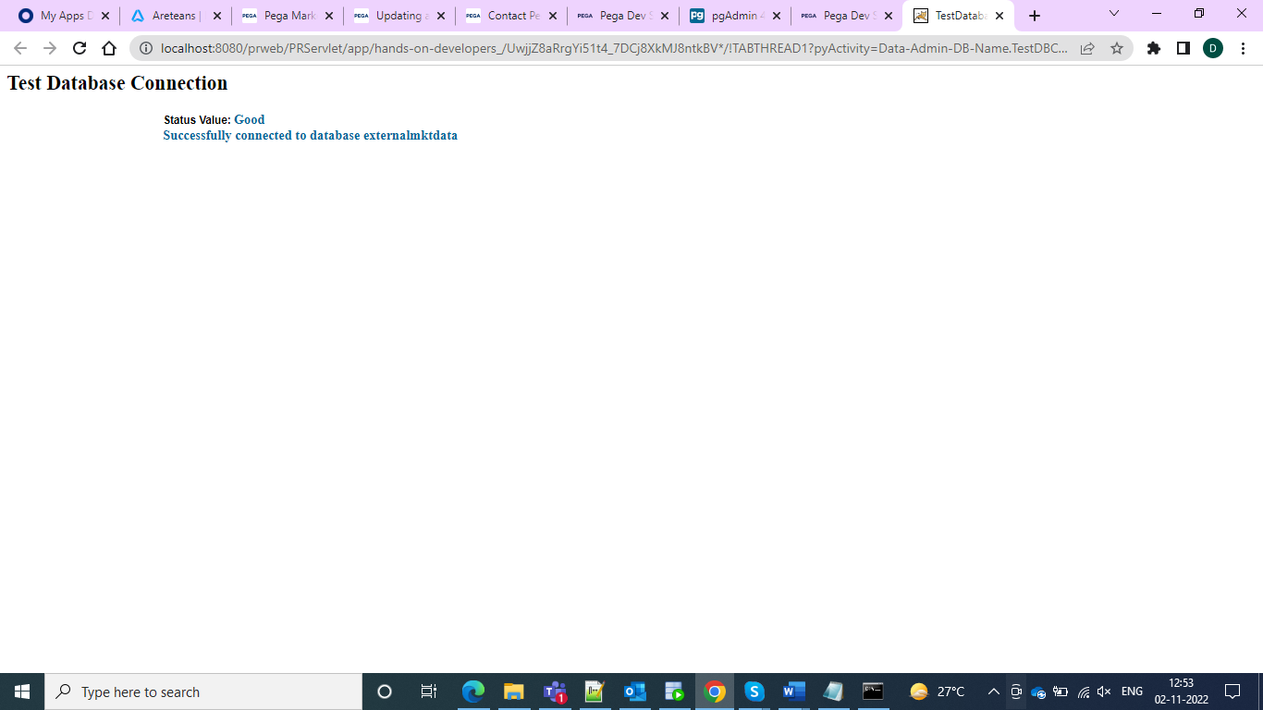

And we can import the CDH file Zip

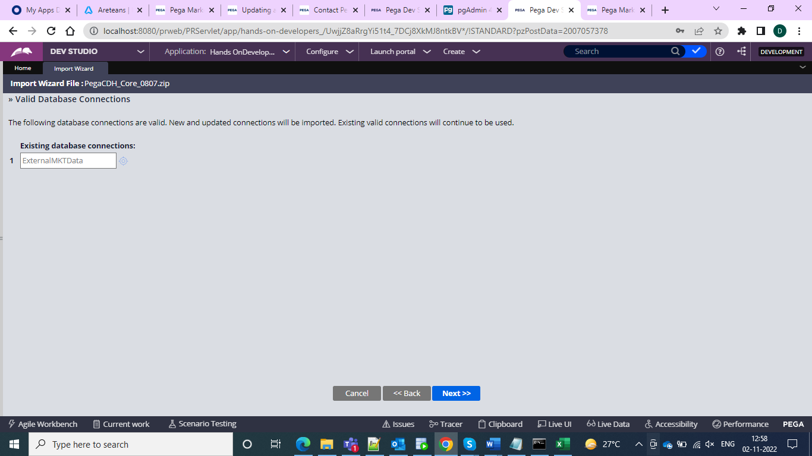

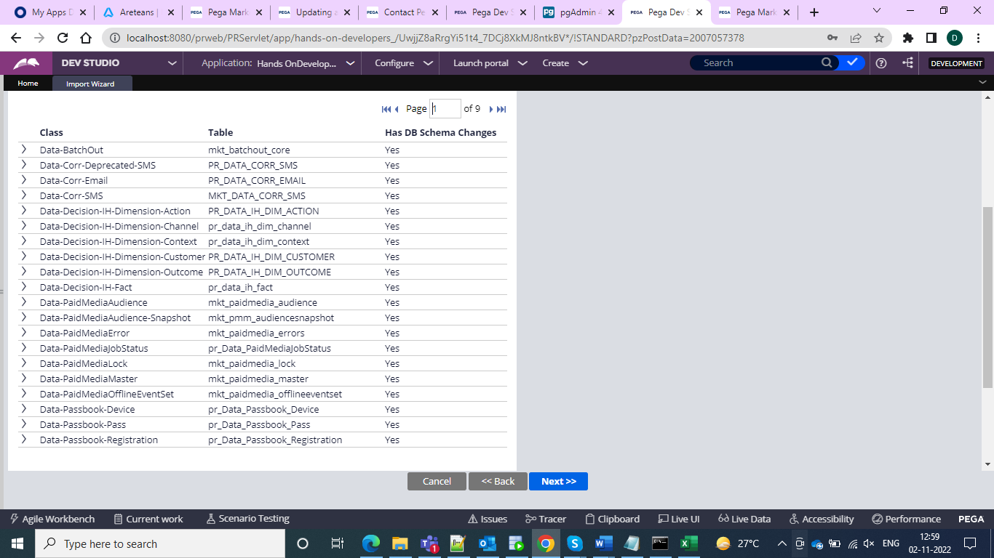

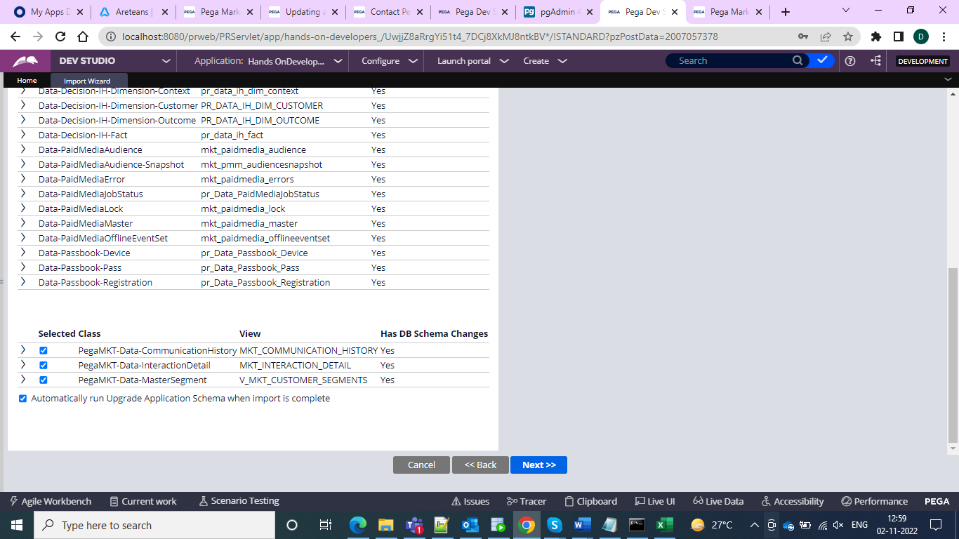

And we can get the import and after the import, you would find the completion of that CDH

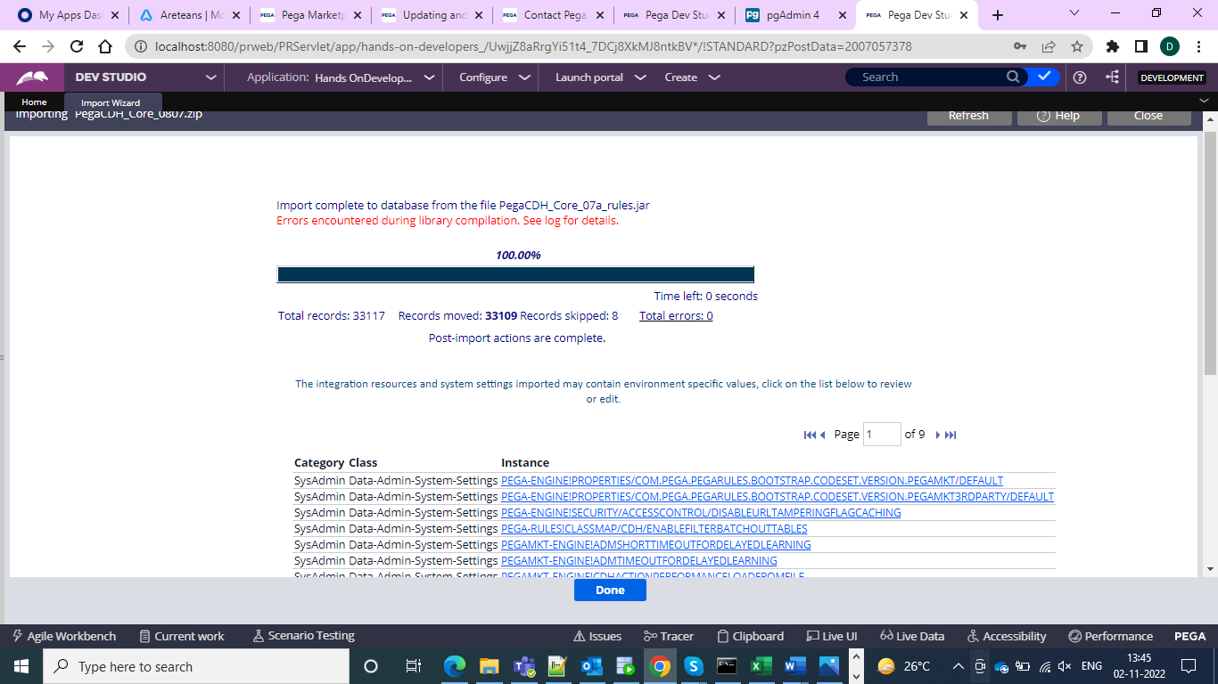

And after that go to the Agent Schedule and and filter with pegaMKT and then for every agent check whether it is enabled or not.  
The agents are

**PegaMKT-Engine • BackgroundProcessing**

**PegaMKT-FieldMarketing • BackgroundProcessing**

**PegaMKT-PushNotification • BackgroundProcessing**

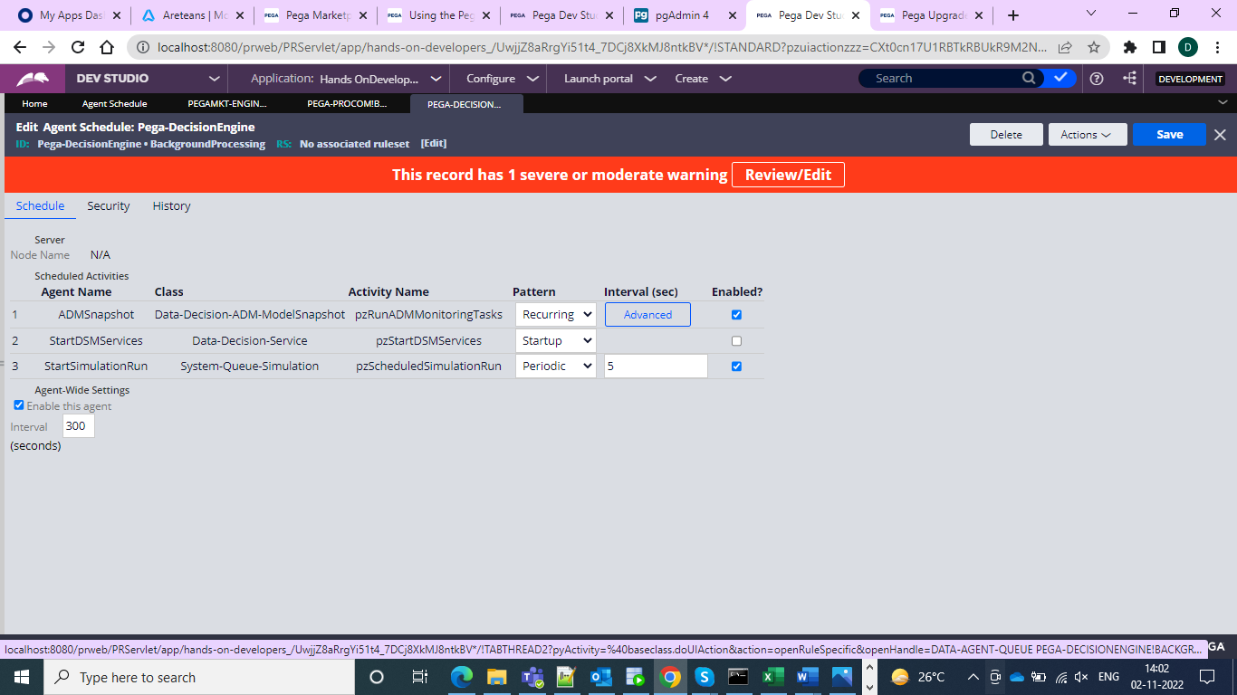

And after that go for another import export Pega export agent and check whether enable or not

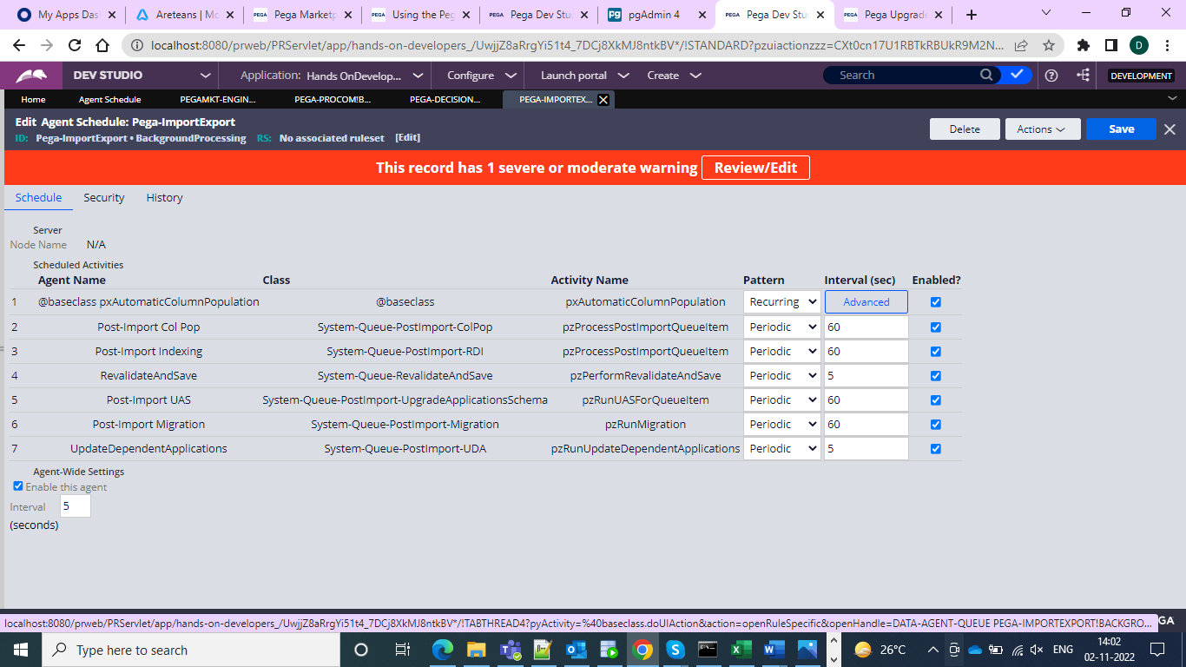

And then go to admin studio and then go for the pzStandardProcessor and enable but if in the application definition under the definition tab under the advanced if the checkbox Include in background processing is not checked then enable otherwise no need.

We also need to enanble the customer decision hub and then we need to go for the context dictionary in app studio and then sve it and then overwrite all rules and then wait until it completes. Then the NBA desigfner will be enabled

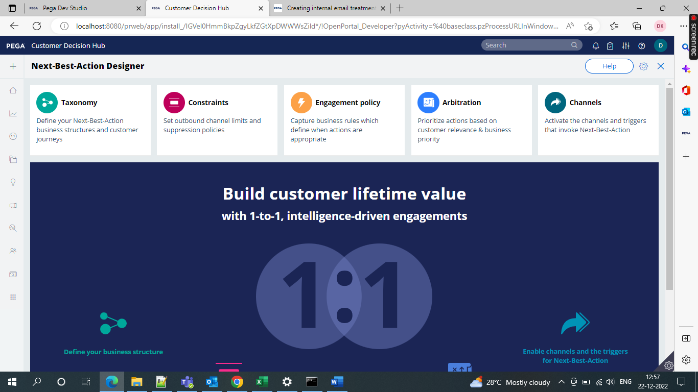

We need to enable the Pega Customer Decision Hub Marketing Campaign Edition

Follow these steps

Go to a sysadmin in records and then go for the Application Settings go to EnableCampaignEdition

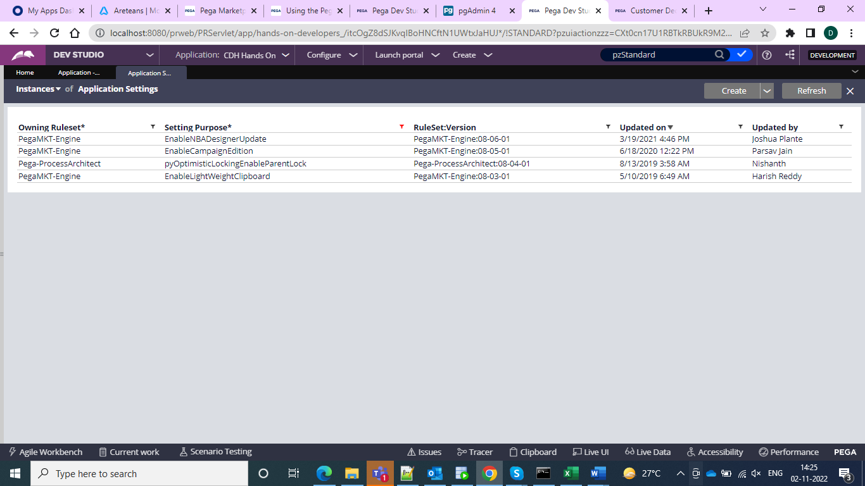

And keep it in the implementation ruleset and under that please select the production levels to True.  
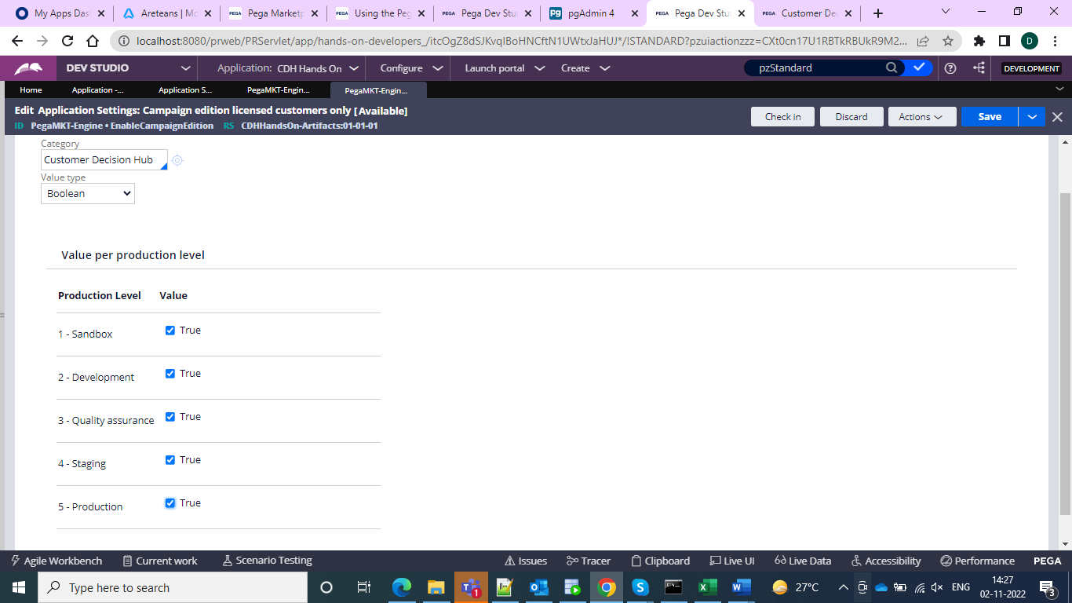

And click save and check-in

And inside the Check-In comments specify the enabled marketing campaign edition

And after doing all this yup you are ready to use your application.